


Arnside National School
Church Hill, Arnside
Carnforth, Lancs
LA5 0DW
Email: admin@arnside.cumbria.sch.uk
www.arnside.cumbria.sch.uk/index.html
Tel/Fax: 01524 761159

NSS – National Support School
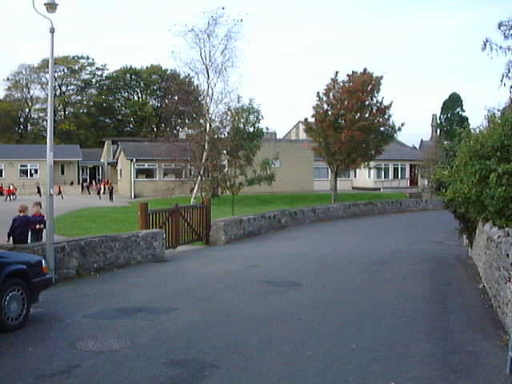






Headteacher: Mr A R Cook B.Ed(Hons) NLE National Leader of Education Telephone & Fax: (01524) 761159

13th September 2010
Dear Governor

The next meeting of the Governing Body will be held in school on Tuesday 21st September at 7.30pm.

AGENDA

- Declarations of Interest in respect of Agenda Items
- Apologies
- Minutes of the last meeting
- Matters Arising
- Governors’ Business Interests
- Election of Officers:
Attendance & Safeguarding Children; SEN; Literacy, Numeracy, Link Governor
- Election of Committees (Terms of Reference):
Finance; Performance Management Appeals; Building risk assessment; Staff Discipline/Grievance; Staff Discipline Appeals; Pupil Discipline; Admission; Complaints.
- Headteacher’s Report
- Buildings Report
- Finance Report
- Local Authority Annual Report to Governors. Priorities for 2010 - 2011
- Nursery provision update
- Academy status
- AOB – if you have any issue you would like to raise please notify Mrs Inchmore with details of the item at least 24 hours before the next meeting
- Date of next meeting

