Day | Literacy | Maths | Curriculum
Mon | Lesson 1 – The Princess and the Pea  Use the following link: https://www.hamilton-trust.org.uk/blog/learning-home-packs/  > Learning at Home Packs for English  > Year 4 English Week 1  > Year 4 Day 1  Children read the story, complete activities and create a storyboard. | Lesson 1 – Recognise tenths and hundredths  Click on the following link:  https://whiterosemaths.com/homelearning/year-4/ and click on Lesson 1  Watch the video clip which explains the mathematical concepts and follow the link to ‘Get the Activity’. The children can then complete the activity and check their answers.  Maths Mastery :  https://www.twinkl.co.uk/resource/year-4-diving-into-mastery-make-a-whole-teaching-pack-t-m-31547 | Charanga Music – Dancing in the Street  https://www.cumbriacharanga.co.uk/yumu/login  Logon to the above link and complete session 1  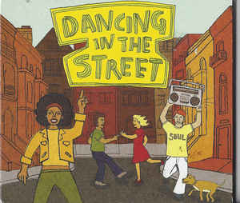
Tues | Lesson 2 – Dialogue  Use the following link: https://www.hamilton-trust.org.uk/blog/learning-home-packs/  > Learning at Home Packs for English  > Year 4 English Week 1  > Year 4 Day 2  Children re-read the story, complete activities and create speech dialogue for a garden scene. | Lesson 2 – Tenths as Decimals  Click on the following link:  https://whiterosemaths.com/homelearning/year-4/ and click on Lesson 2  Watch the video clip which explains the mathematical concepts and follow the link to ‘Get the Activity’. The children can then complete the activity and check their answers. | Science – What is a Force  Watch the two video clips below:  https://www.bbc.co.uk/bitesize/topics/zvpp34j/articles/zywcrdm  https://www.bbc.co.uk/bitesize/topics/zsxxsbk/articles/zxw6gdm  Complete the following investigation:  https://www.twinkl.co.uk/resource/science-forces-year-5-home-learning-tasks-tp2-s-300
Wed | Lesson 3 – Speech Punctuation  Use the following link: https://www.hamilton-trust.org.uk/blog/learning-home-packs/  > Learning at Home Packs for English  > Year 4 English Week 1  > Year 4 Day 3  Children re-read the story, complete activities and practice speech punctuation. | Lesson 3 – Tenths on a Place Value Grid  Click on the following link:  https://whiterosemaths.com/homelearning/year-4/ and click on Lesson 3  Watch the video clip which explains the mathematical concepts and follow the link to ‘Get the Activity’. The children can then complete the activity and check their answers. | Lake District Topic Lesson 1 – Mountains Create a Poster  Click on the following link:  https://www.bbc.co.uk/bitesize/topics/z3fycdm/articles/zvys8xs  Task: Create a factfile/poster about a Lake District Mountain range of your choice. You could include information about how mountains are formed –  https://www.bbc.co.uk/bitesize/topics/z849q6f/articles/z4g3qp3
Thurs | Lesson 4 - Poetry  Use the following link: https://www.hamilton-trust.org.uk/blog/learning-home-packs/  > Learning at Home Packs for English  > Year 4 English Week 1  > Year 4 Day 4  Children read the poems and complete the activities. | Lesson 4 – Tenths on a number Line  Click on the following link:  https://whiterosemaths.com/homelearning/year-4/ and click on Lesson 4  Watch the video clip which explains the mathematical concepts and follow the link to ‘Get the Activity’. The children can then complete the activity and check their answers. | Art/Design – Observational Drawing  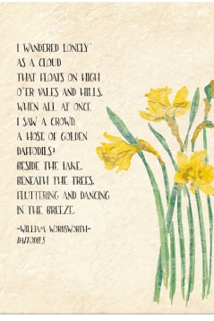  Handwriting – Write a verse of the William Wordsworth Poem – ‘I wandered lonely as a cloud’  Observational Drawing - Use either daffodils from your garden or look on ‘Google images’ - create an observational drawing of a daffodil to illustrate your poem.
Fri | Lesson 5 – Poetry  Use the following link: https://www.hamilton-trust.org.uk/blog/learning-home-packs/  > Learning at Home Packs for English  > Year 4 English Week 1  > Year 4 Day 5  Children read the poems and complete the activities. | Lesson 5 – Dividing 1 Digit by 10  Click on the following link:  https://whiterosemaths.com/homelearning/year-4/ and click on Lesson 5  Watch the video clip which explains the mathematical concepts and follow the link to ‘Get the Activity’. The children can then complete the activity and check their answers. | Arnside Archive  The Arnside Archive Group have invited the people of Arnside to write a diary about your experiences during the Covid-19 Pandemic. Each week the children could write a diary entry for the week. This could be a family diary, photos, pictures, jokes, practical tips etc.  Activity – Write your diary entry for the previous week.
Year 4 Week 1

