


Arnside National School
Church Hill, Arnside
Carnforth, Lancs
LA5 0DW
Email: admin@arnside.cumbria.sch.uk
www.arnside.cumbria.sch.uk/index.html
Tel/Fax: 01524 761159

NSS – National Support School
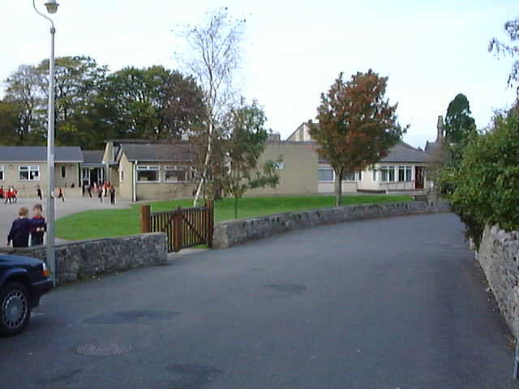






Headteacher: Mr A R Cook B.Ed(Hons) NLE National Leader of Education Telephone & Fax: (01524) 761159

15th April 2010

Dear Governor

The next meeting of the Governing Body will be held in school on Tuesday 27th April at 7.30pm.

AGENDA

- Apologies
- Declarations of Interest in respect of Agenda Items
- Minutes of last meeting
- Matters Arising
- Headteacher’s Report
- Treasurer’s Report
- Building Report
- Budget 2010 - 2011
- Staffing class organisation 2010 - 2011
- SATS 2010
- Safeguarding
- Nursery provison
- AOB – if you have any issue you would like to raise please notify Mrs Inchmore with details of the item at least 24 hours before the meeting
- Date of next meeting

